Python & Jupyter Notebook Installation Guide

This installation guide will explain how to install & setup Python, Jupyter Notebook, and some packages for your participation in this workshop. This guide assumes windows distribution.

1. Install latest version of Anaconda here: <https://www.anaconda.com/products/distribution>. Follow the default settings provided with the installation.
2. In your windows menu, find Anaconda and open Jupyter notebook

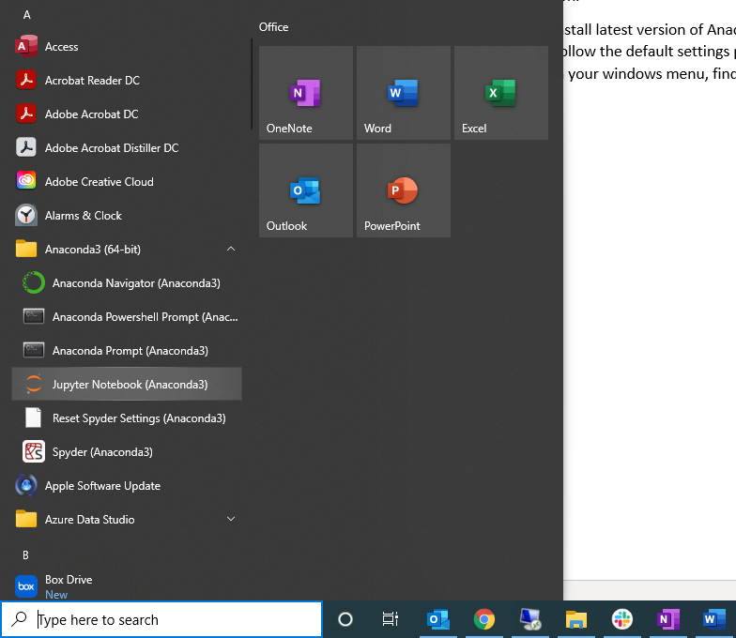

1. Jupyter notebook will open in your web browser. Navigate within it to your desktop or another drive where you want to save the notebooks you will use for this course.
2. Create a new notebook by clicking New > Python 3

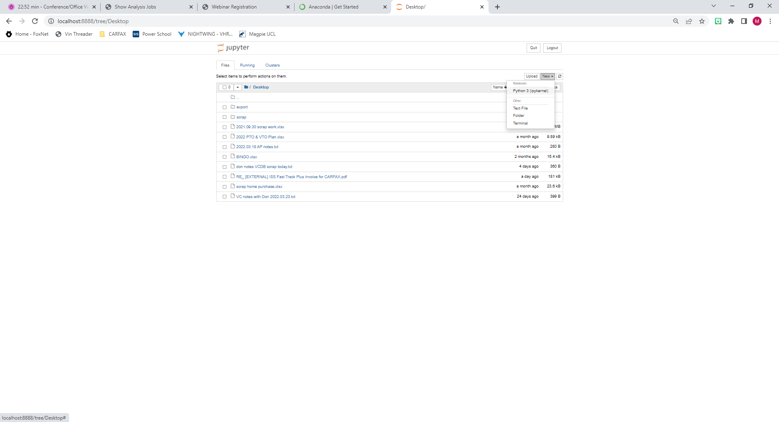

1. Rename the notebook by clicking on ‘Untitled’ near the top and type your notebook name.

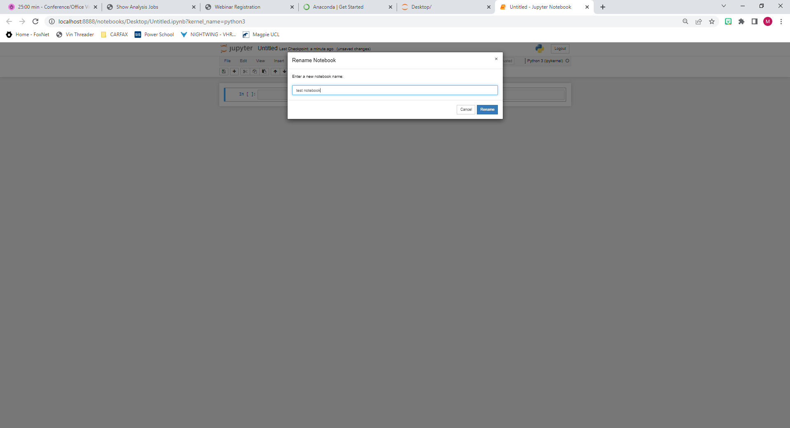

1. In the first cell type: print(‘Hello World’). Execute the cell by hitting CTRL+Enter.

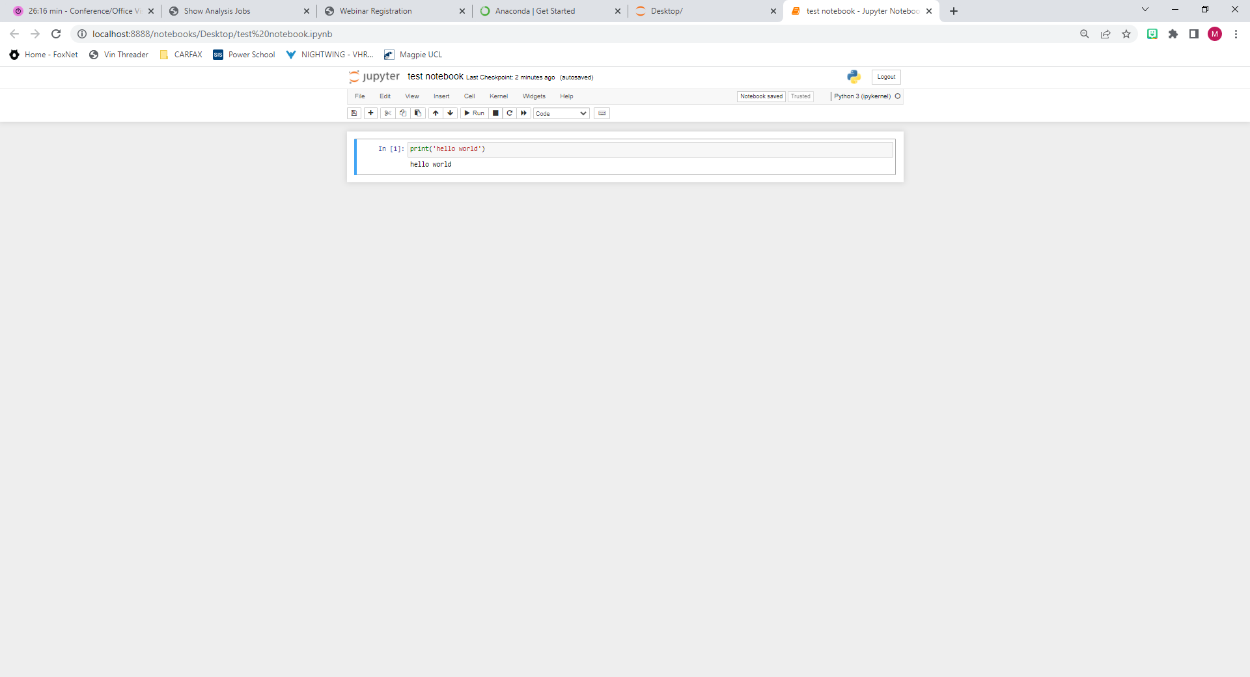

1. We will install the packages we need as we go through the course but to get started we need to install numpy and pandas. Add a new cell by hitting the ‘+’ button in the toolbar.



1. Type: pip install numpy pandas and execute the cell by hitting CTRL + Enter

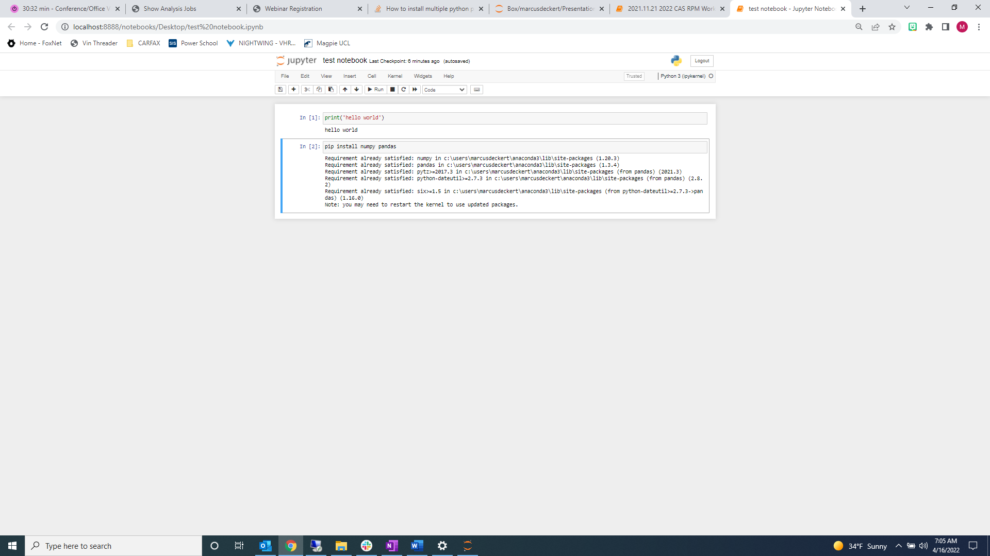

1. Restart the Kernel.

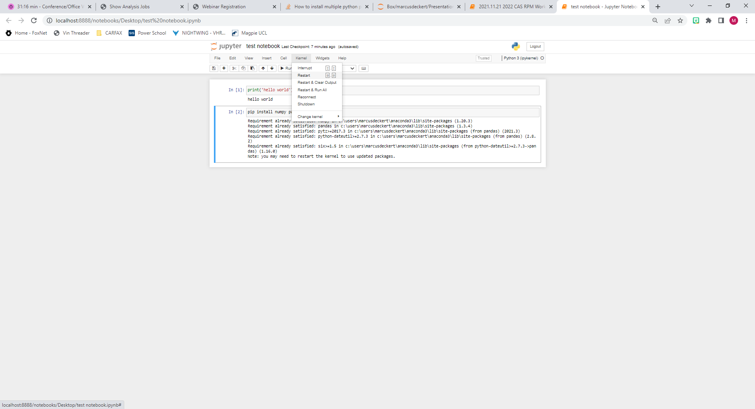

1. Now you are ready for the course. You can close the webpage and also within your windows tray you will find anaconda running. You may close that as well when you are finished.